Phases of the Data Science Life Cycle
The data science life cycle typically follows eight key phases. Each stage builds on the previous one to ensure reliable, repeatable outcomes.
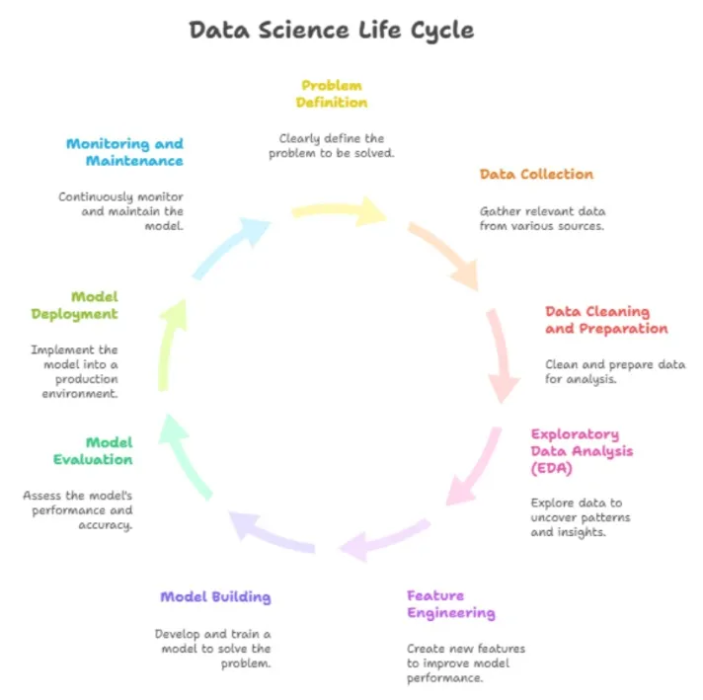

Phase 1: Problem Definition and Business Understanding
The process begins with understanding the business objective. You define what question you’re trying to answer and what success looks like.
Key tasks
- Identify the problem clearly.
- Define goals, KPIs, and measurable outcomes.
- Collect context from domain experts and stakeholders.
- Translate business problems into data science questions.
Example:
A retail company wants to reduce customer churn. The data science team defines the target variable (churn = yes/no) and sets a success metric (increase retention by 5%).
Tools used
- Stakeholder maps
- Requirement gathering templates
- Google Docs, Miro, JIRA
Output: A documented business problem statement with clear objectives.
Also Read: Common Career Mistakes in Data Science and How to Avoid Them

Phase 2: Data Collection and Acquisition
Once objectives are set, the next step is collecting data from internal and external sources. The quality and quantity of data directly affect project outcomes.
Key tasks
- Identify data sources (databases, APIs, sensors, etc.)
- Gather structured and unstructured data.
- Handle data ingestion and storage.
- Record metadata for traceability.
Tools used
- Python (Requests, BeautifulSoup)
- SQL, PostgreSQL, MongoDB
- AWS S3, Google BigQuery, Snowflake
Output: Raw dataset with metadata describing origin, type, and limitations.
Also Read: Data Collection Types Explained: Methods & Key Steps

Phase 3: Data Cleaning and Preparation
Raw data is rarely usable. This phase focuses on transforming and preparing data for analysis.
Key tasks
- Handle missing values and duplicates.
- Fix inconsistencies in formats and encodings.
- Perform feature engineering and data normalization.
- Split data into training and testing sets.
Tools used
- Python (Pandas, NumPy)
- R, Excel, Power Query
- Apache Spark for large-scale processing
Example table: Common Data Cleaning Steps
Task | Description | Example Tool
Handle missing values | Replace or drop NA fields | Pandas
Remove duplicates | Drop redundant rows | SQL DISTINCT
Feature scaling | Normalize numerical data | Scikit-learn
Encoding | Convert categorical data | OneHotEncoder
Output: Clean, well-structured dataset ready for analysis.
Also Read: Data Cleaning Techniques: 15 Simple & Effective Ways To Clean Data

Phase 4: Exploratory Data Analysis (EDA) and Visualization
EDA helps uncover trends, patterns, and relationships within the data. It combines statistical techniques and visual storytelling.
Key tasks
- Generate summary statistics and distribution plots.
- Identify correlations and outliers.
- Detect data biases.
- Visualize trends to refine hypotheses.
Tools used
- Python: Matplotlib, Seaborn, Plotly
- R: ggplot2
- Tableau, Power BI
Example:
Plot histograms to understand income distribution, scatter plots for feature correlations, or heatmaps for missing data patterns.
Output: Insights and hypotheses that shape the modeling approach.
Also Read: Getting Started with Data Exploration: A Beginner's Guide

Phase 5: Modeling and Algorithm Development
Here, data scientists apply machine learning algorithms to train predictive or descriptive models.
Key tasks
- Select suitable algorithms (regression, classification, clustering).
- Train and tune models on prepared data.
- Use feature selection and dimensionality reduction.
- Evaluate model performance through metrics.
Tools used
- Scikit-learn, TensorFlow, PyTorch
- XGBoost, CatBoost, LightGBM
- R (caret, mlr)
Example models
- Linear Regression for price prediction
- Logistic Regression for churn classification
- Random Forest for feature importance
- K-Means for customer segmentation
Output: Trained model with recorded parameters and performance scores.

Phase 6: Evaluation and Validation
This phase checks whether the model meets performance expectations and business goals.
Key tasks
- Test models on validation and unseen datasets.
- Compare results using metrics such as accuracy, F1-score, RMSE, or AUC.
- Check alignment with business KPIs.
- Perform error analysis to understand misclassifications.
Tools used
- Scikit-learn metrics
- MLflow, W&B (Weights and Biases)
- Custom dashboards for result visualization
Example metrics table
Model | Accuracy | Precision | Recall | F1-score
Logistic Regression | 0.86 | 0.82 | 0.85 | 0.83
Random Forest | 0.89 | 0.87 | 0.88 | 0.87
Output: Validated model with documented performance and potential improvements.
Also Read: Evaluation Metrics in Machine Learning: Top 10 Metrics You Should Know

Phase 7: Deployment and Integration
Once validated, the model moves into production. It becomes part of a live application or system where users can access predictions.
Key tasks
- Package model into deployable format (API, container, or web app).
- Integrate with front-end applications or business workflows.
- Manage pipelines and schedule model runs.
- Ensure scalability and security.
Tools used
- Flask, FastAPI, Django
- Docker, Kubernetes, Jenkins
- AWS SageMaker, Google AI Platform
Output: Deployed model accessible to users or systems.
Also Read: Guide to Deploying Machine Learning Models on Heroku: Steps, Challenges, and Best Practices

Phase 8: Monitoring, Maintenance, and Iteration
Deployment is not the end. Models need continuous monitoring to stay relevant as data or conditions change.
Key tasks
- Track model drift and performance decay.
- Monitor system uptime and latency.
- Collect user feedback.
- Schedule retraining cycles.
Tools used
- Prometheus, Grafana, Evidently AI
- MLflow tracking servers
- Log management tools (ELK Stack)
Output
- Monitored, retrained, and updated model ensuring long-term accuracy.

Tools and Technologies for Each Phase
Phase | Common Tools | Purpose
Problem Definition | JIRA, Trello | Planning and communication
Data Collection | APIs, SQL, Snowflake | Data sourcing
Data Cleaning | Pandas, R | Preprocessing
EDA | Seaborn, Tableau | Pattern discovery
Modeling | TensorFlow, Scikit-learn | Training algorithms
Evaluation | MLflow | Tracking results
Deployment | Docker, AWS | Serving models
Monitoring | Prometheus | Model maintenance
Frameworks used across phases:
- CRISP-DM: Standardized model for analytics projects.
- Agile Data Science: Iterative collaboration between teams.
- End-to-End ML Pipelines: Automated workflows for continuous delivery.
Each phase in the data science life cycle builds on the previous one. Together, they create a clear path from raw data to real-world impact.
Also Read: Python Pandas Tutorial: Everything Beginners Need to Know about Python Pandas

